**Mario Romañach Paniagua (1917, Havana - 1984, Philadelphia), Architect, Urbanist**

Based on the quality of design in his projects both built and unbuilt, the significant output of work during his relatively short career in Cuba (over seventy built during his eight years in the partnership Bosch y Romañach (1948-1955) with architect Silverio Bosch and five years as a lone practitioner), and a consensus amongst critics both contemporary and current, Mario Romañach is generally regarded as Cuba’s most talented modern architect. A creative individual passionately dedicated to rational architectonic experimentation as well as a designer with a sensible interest in traditional spatial systems and formal composition, both local as well as foreign, he generated a body of work that reflected a careful balance between an international modernity and Cuba’s colonial past.

Mario Romanach was born into a creative household, the son of an architect of the same name and the nephew of Leopoldo Romañach, a noted Cuban post-impressionist painter. He began his architectural training at the University of Havana, graduating from said institution in 1945. After briefly working for the Ministry of Public Works, a period during which he was involved in the design of one of Pre-Revolutionary Cuba’s few public housing projects, the Bario Obrero de Luyanó (*Worker’s Neighborhood of Luyanó*, 1948), along with Pedro Martínez Inclán, Antonio Quintana Simonetti, and Jorge Mantilla. In 1948, he teamed with Silverio Bosch forming a partnership best known for its residential work in the expanding suburbs of mid-century Havana.

Romañach’s early work reflects a more concerted focus on functionalist spatial and structural solutions and the integration of a pallet of modern materials, best exemplified in the House of José Noval Cueto (1949). Rather than accept an international aesthetic often associated with functionalist design, however, the Noval house demonstrates a reconciliation between modern materiality (in particular the generous transparent glazing of the detached double height living room) and the tropical language that enabled the use of such out-of-place architectural gestures (such as a generous roof overhang as well as a strategic placing of pools of water that echo the use of fountains in Spanish colonial as well as Islamic architectural spaces).

A shift in Romanach’s architectural expression becomes apparent by 1953 with the completion of the House of Evangelina Aristigueta de Vidaña. In this work, which won the National College of Architects Gold Medal for the best residence completed in Cuba between 1953 and 1955, a renewed focus on the natural aesthetic and structural properties of the materials involved is strongly apparent, thus paralleling a tendency visible in the contemporary language of the New Brutalists. This stylistic phase in his career reached its nadir shortly after parting ways with Bosch with the completion of the Apartments for the Compañia Territorial La Sierra, S.A. (1956), an elegant four-story structure marked by its bold exposition of white-rendered columns and deep beams. In a marked turn from the relative transparency of his earlier single-family residential projects and in response to need to limit the exposure of interior space to the tropical sun, this multi-family dwelling demonstrates the increasing spatial hermeticism that marks Romañach’s latter work. Individual apartments are almost wholly sealed off from the exterior with exposed brick walls, punctured only by projecting balconies protected by clay screens or thin wooden jalousies in a manner not unlike the Arabic *mashrabiya.*

In a third stylistic transition that marks the end of his career in Havana, Romañach renewed his search for the creation of a properly proportioned space of habitat for his buildings occupants. This time, his inspiration drew not from the Ibero-Arabic tradition present in the architecture of Cuba’s colonial period, but rather from Japanese tradition, integrating in particular the language of the *shoin-zukuri* style as well as utilizing the *ken* module. The House of Ana Carolina Font (1956), also referred to as the “Butterfly House” due to its signature projecting V-shaped roofs, is an excellent example of this stylistic shift with its dramatic exposed roof beams, while the insular spaces for the Apartments for the *Compañia de Inversiones en Bienes y Bonos S.A.* (1956-8) are most blatantly organized on the *ken* system, artfully integrating the formerly ceremonial *toko-no-ma,* or decorative alcove, into the functional spaces of habitation. This period is culminated with his masterwork, the House of Rufino Alvarez (1957), an expansive residence arranged around a series of patios and marked by a careful synthesis of enclosure and exposure through artfully designed masonry screens and light filters as well as Japanese *fusuma,* or sliding partitions.

Romañach was involved in the major urban and planning projects of his day, working after 1955 along with Josep Lluís Sert, Paul Lester Wiener and the Cuban *Junta Nacional de Planificación* (JNP) as the director of the Regulatory Plan for Metropolitan Havana. During this collaboration, he also worked on the unbuilt Presidential Palace project (1956-58).

At the time of the Cuban revolution in 1959, Romañach was a visiting critic at Harvard’s Graduate School of Design. He returned briefly to Cuba, deciding to leave for exile in 1960. He continued to practice in the United States, and received a number of academic appointments first at Cornell until departing said institution for the University of Pennsylvania in 1962 where he eventually became the chair of the architecture department from 1971-1974.

Further Reading:

Rodríguez, Eduardo Luís (1998) *La Habana: Arquitectura del Siglo XX,* Barcelona:

Blume.

Rodríguez, Eduardo Luís (2000) *Havana Modern Guide: Modern Architecture 1925-*

*1965,* New York: Princeton Architectural Press.

Gómez Díaz, Francisco (2008) *De Forestier a Sert: ciudad y arquitectura en La*

*Habana de 1925 a 1960,* Madrid: Abada Editores, S.L.

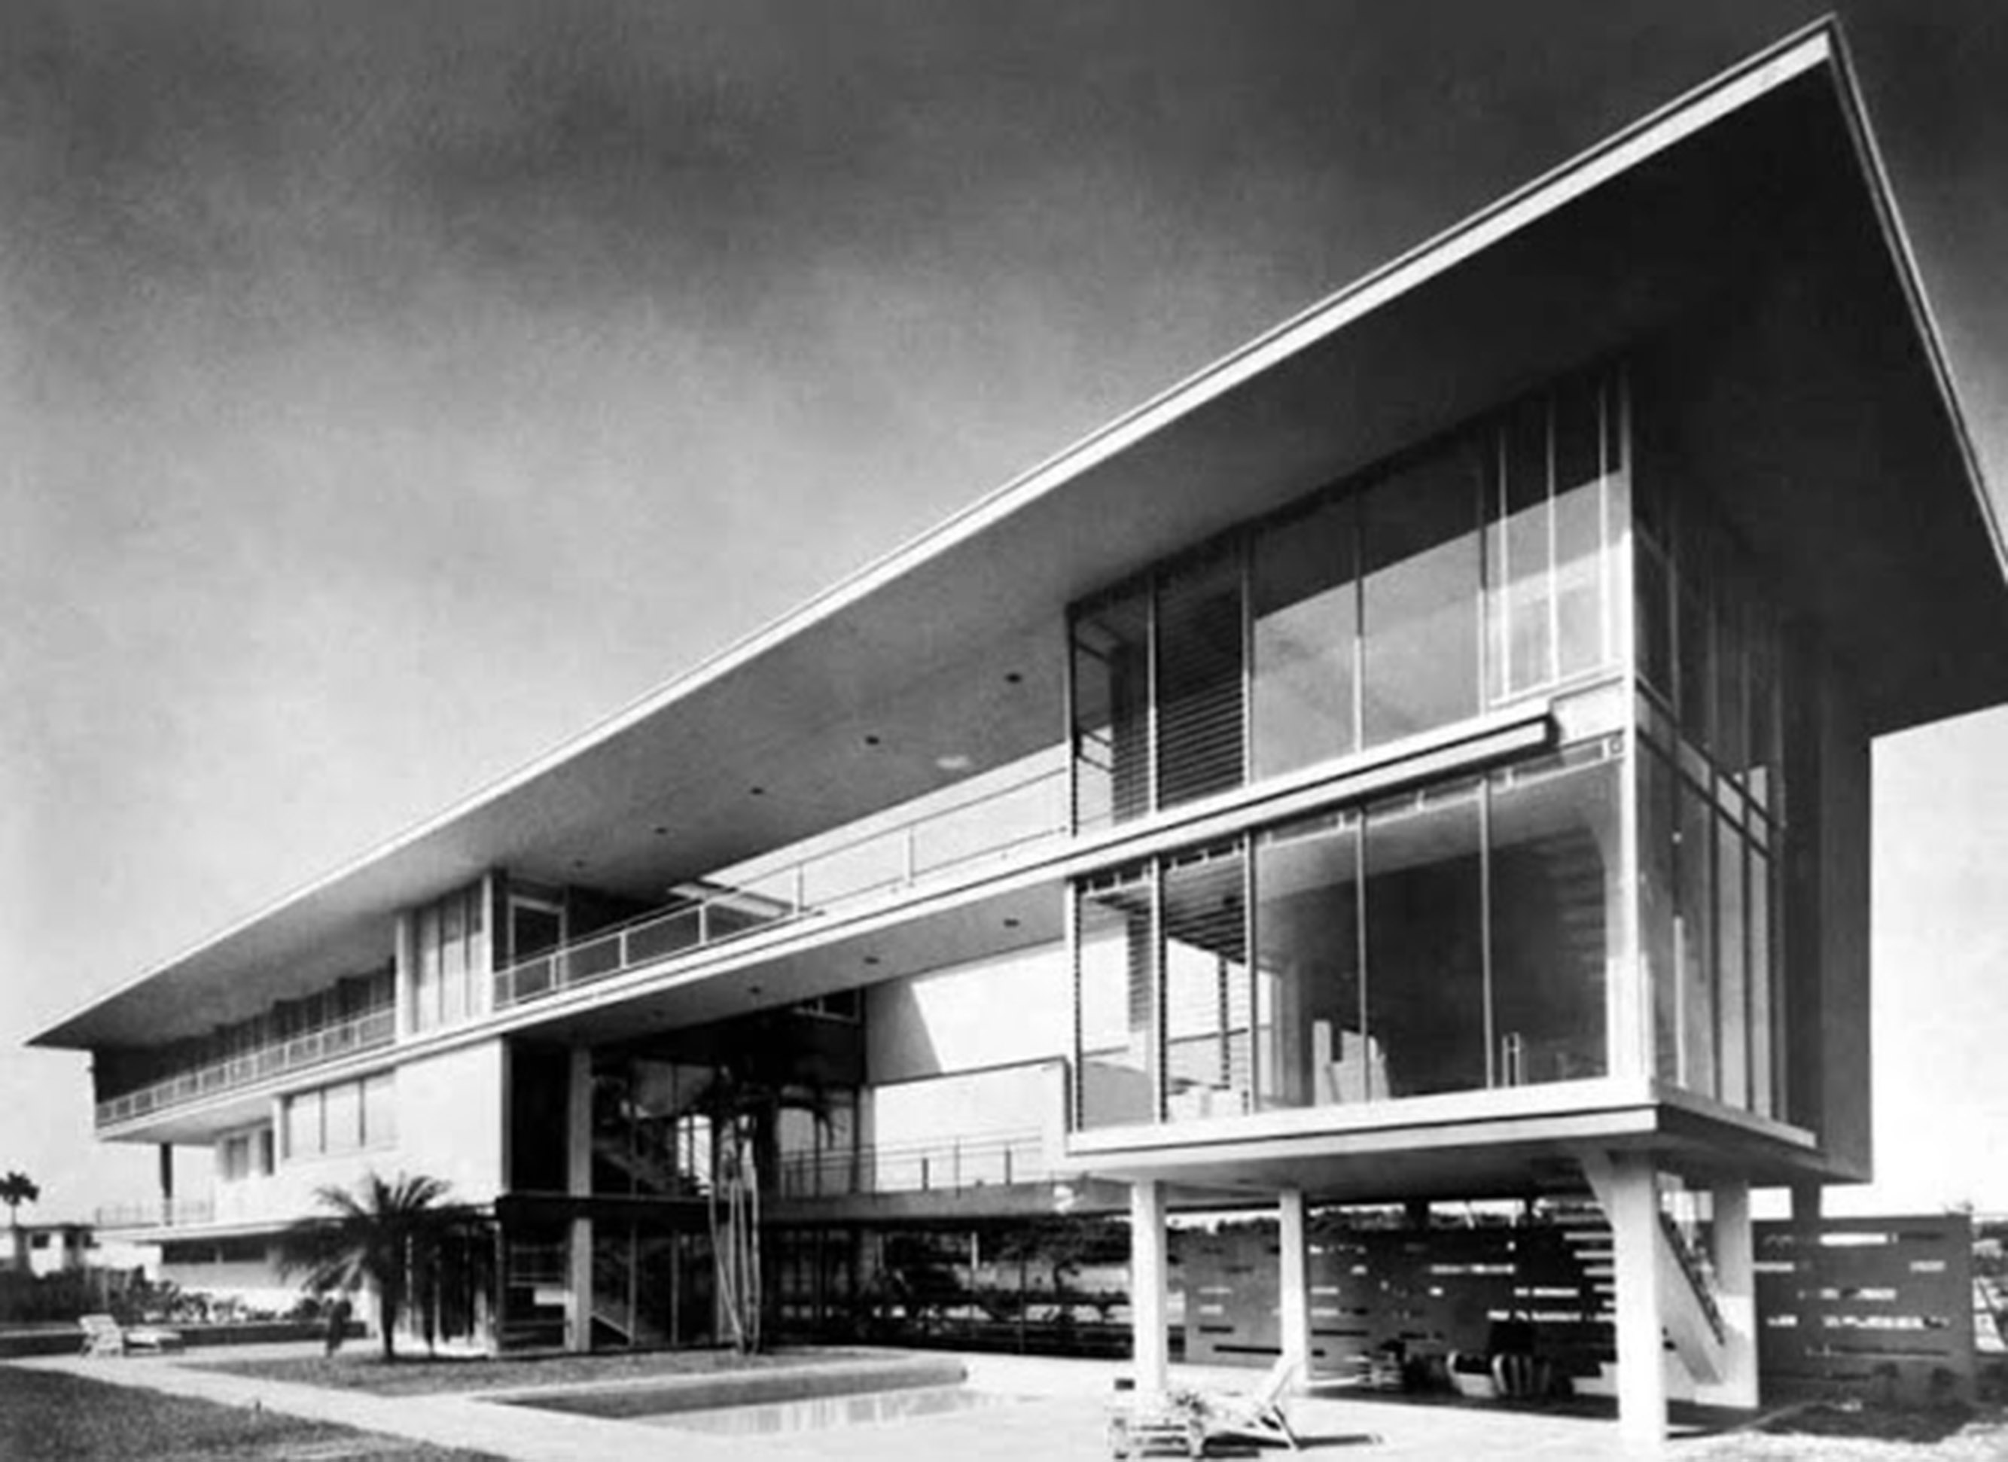

House of José Noval Cueto, 1949. (Image in Docomomo no. 33 September 2005, pg 11 Image cited as © Docomomo International)

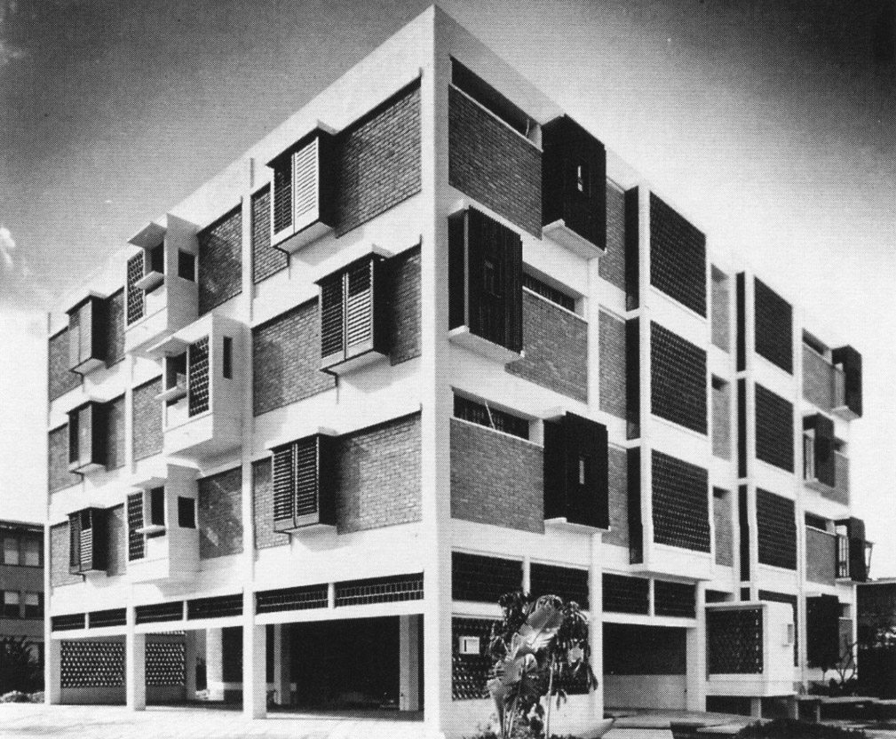

Apartments for the Compañia Territorial La Sierra, S.A., 1956. (Image in *Havana Guide,* pg 100. Author does not credit source – likely from *Arquitectura*)

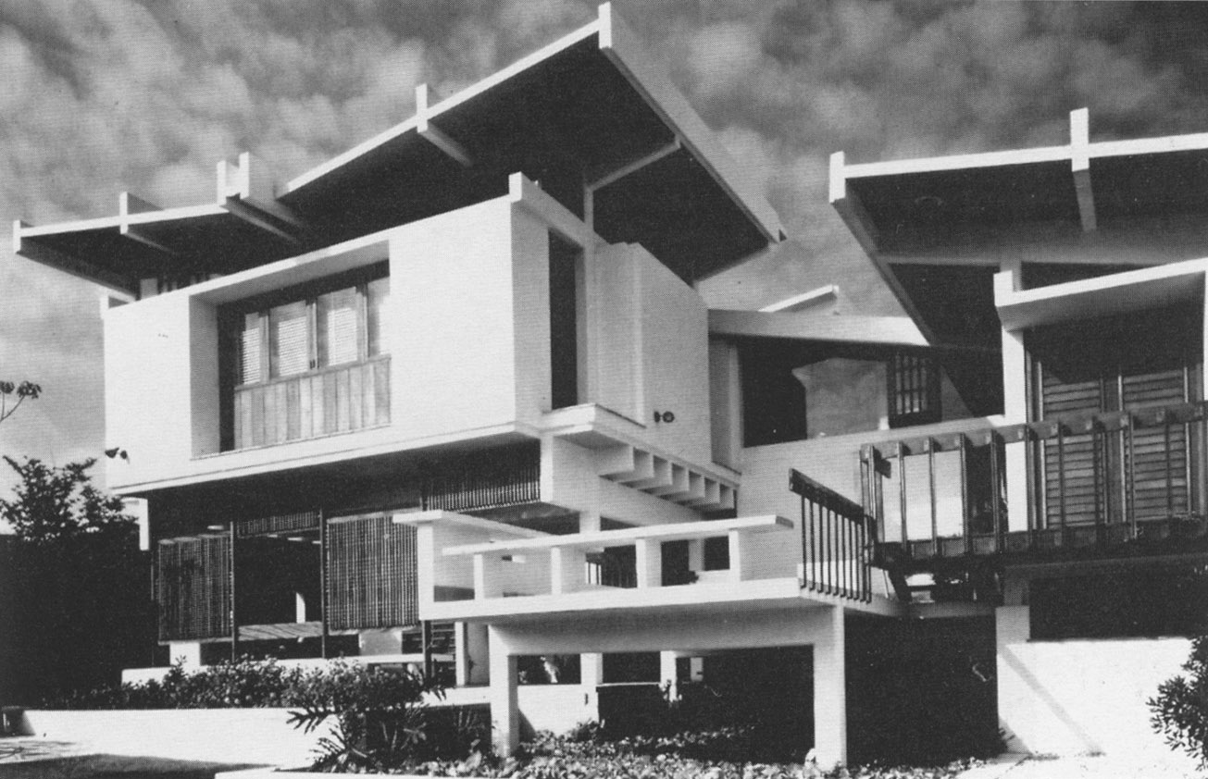

The House of Ana Carolina Font, 1956. (Image in *Havana Guide,* pg 10. Author credits image as belonging to “Servifoto”)

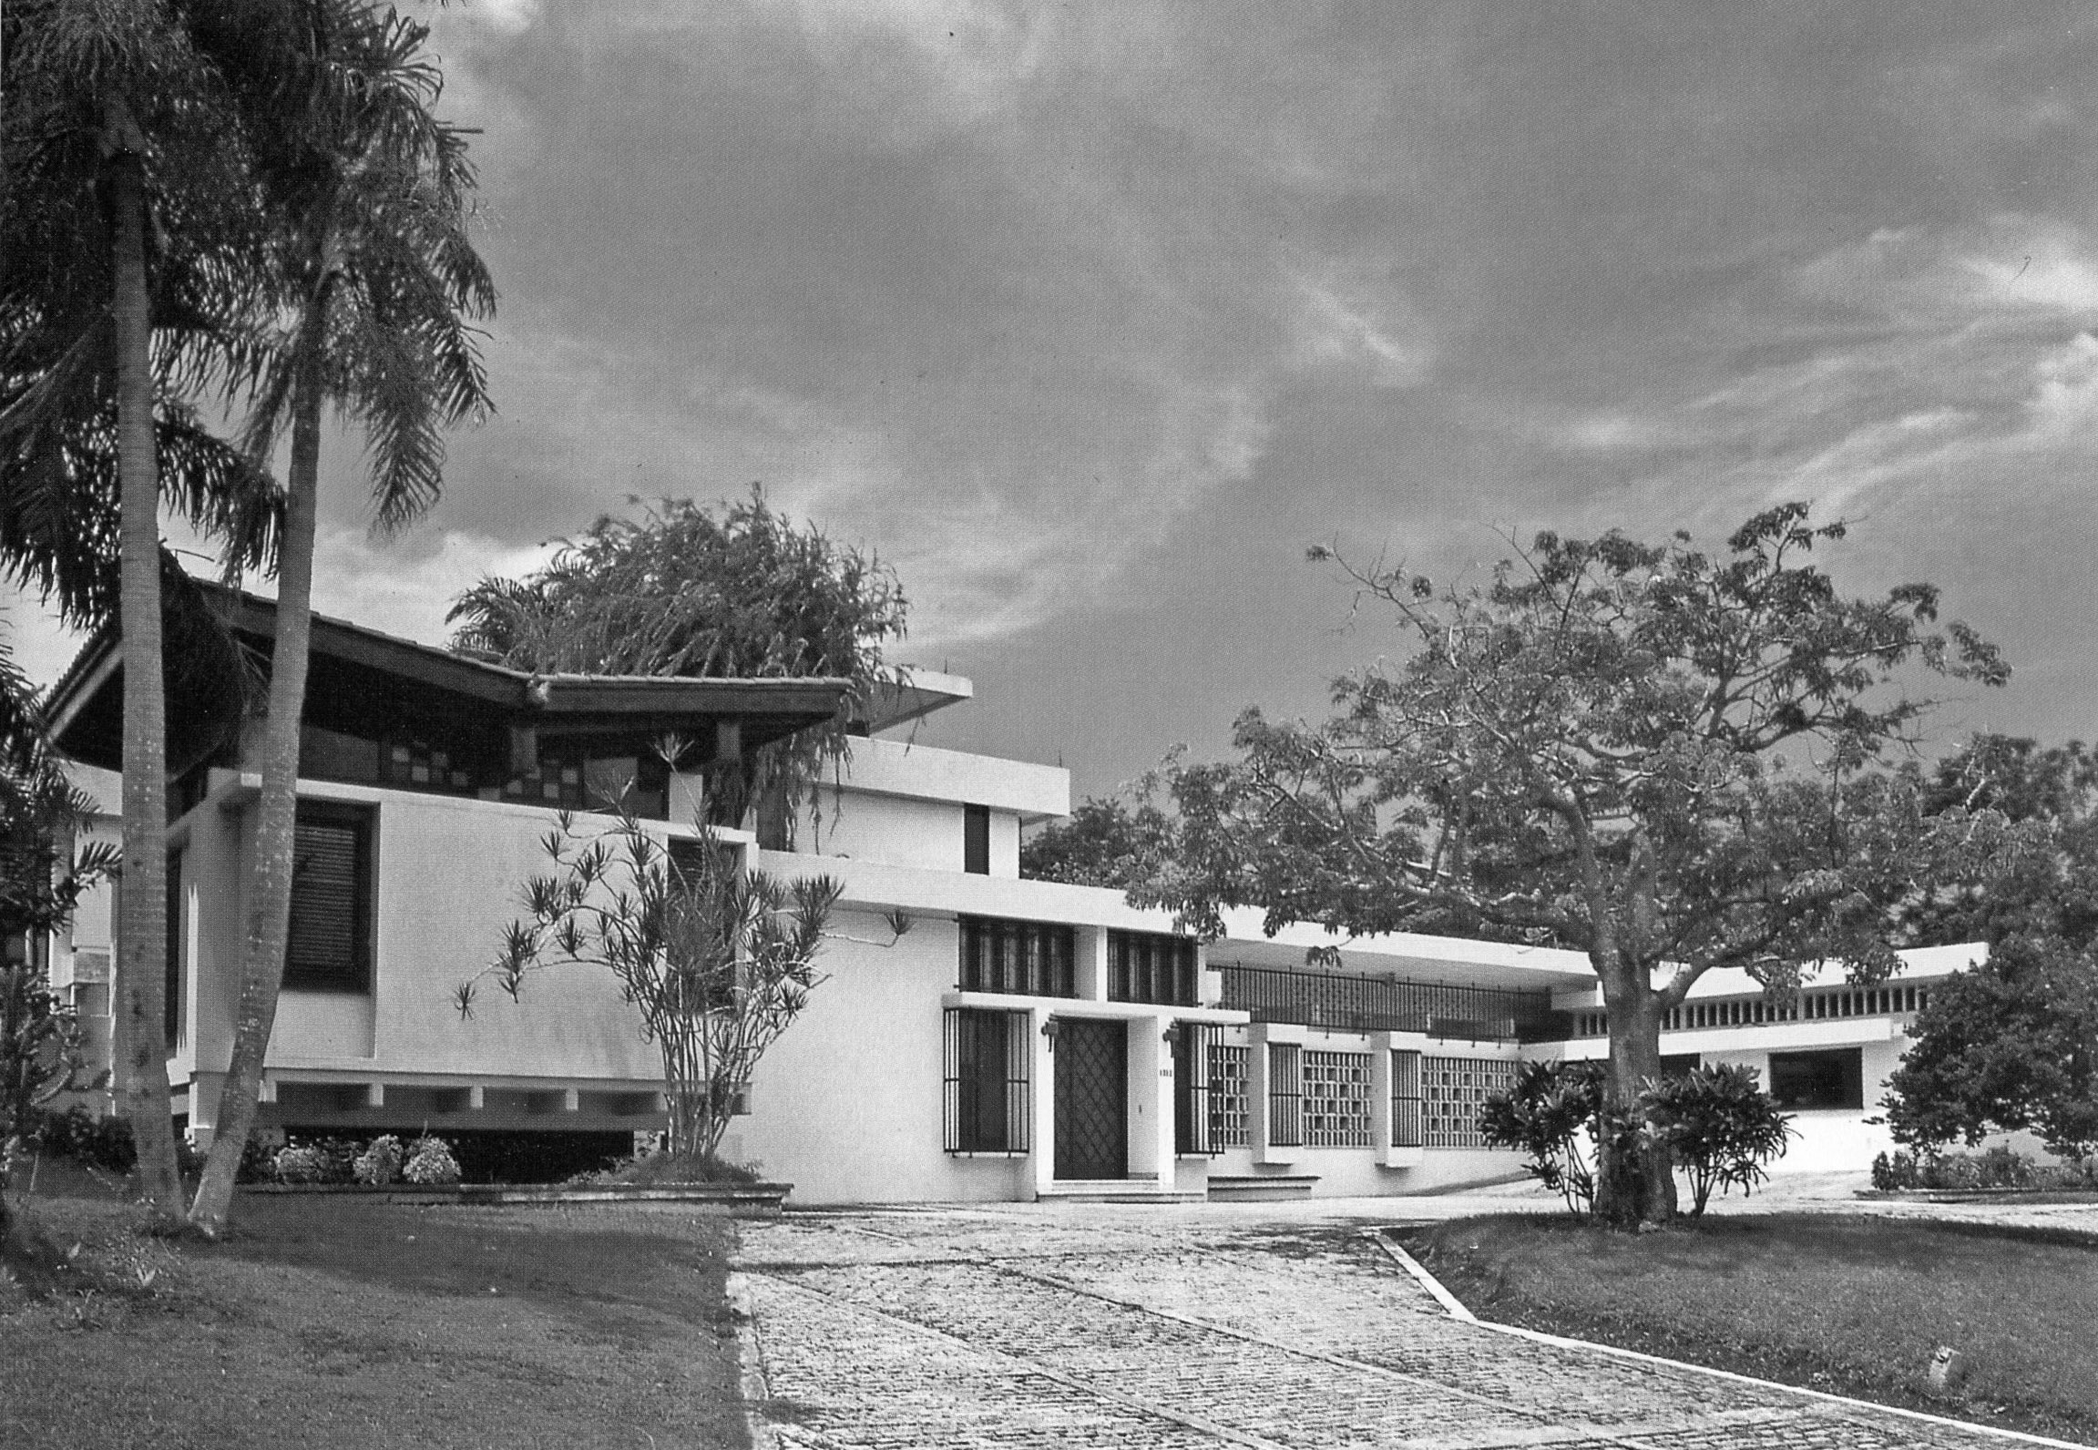

House of Rufino Alvarez, 1957. (Image in Carley, Rachel (1997) *Cuba: 400 Years of Architectural Heritage*: Whitney Library of Design, pg 17. Image by Andrea Brizzi)